DRAFT

Transport of soil water
Mette Lægdsmand, 2007

The soil water is divided into two domains (mobile and immobile). The mobile domain is from field capacity to saturation and the immobile domain is below field capacity. The transfer of water between the two domains ensures that the mobile domain only exist if the total water content exceeds field capacity.

Mobile water
Transport of soil water in the mobile domain is simulated using a simple approach based on the tipping bucket principle: water is only transported downwards and can only be transferred from one layer to the next if the water content exceeds field capacity. The rate of water transfer is determined by the hydrological properties of the soil. The soil water model operates with an hourly time step.

The flux of water percolating from a layer in the soil to the next (q_{w}) is described as
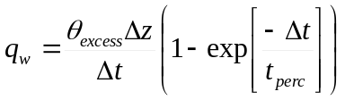
where θ_{excess} is the volumetric water content that exceeds field capacity, Δt is the time step and t_{perc} is the travel time in the layer.

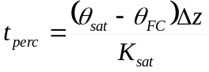
where θ_{sat} is the water content at saturation, θ_{FC} is the volumetric water content at field capacity and K_{sat} is the saturated hydraulic conductivity.

Immobile water

q_{w} | flux of percolating water | m³ m⁻² s⁻¹
θ_{excess} | volumetric water content that exceeds field capacity | m³ m⁻³
Δt | time step | s
Δz | layer thickness | m
t_{perc} | travel time in layer | s
θ_{sat} | volumetric water content at saturation | m³ m⁻³
θ_{FC} | volumetric water content at field capacity | m³ m⁻³
K_{sat} | saturated hydraulic conductivity | m s⁻¹

